MINI PROJECT REPORT

ON

**“ChaosEncoded – Tutorial Website”**

Submitted for the partial fulfillment of the requirement for the

4TH semester

**Bachelor of Technology**

in

**Computer Science & Engineering**

**By**

**Divyanshu**  Reg. No: 2001287093

**Nilesh Mohanty** Reg. No: 2001287123

**Md Afshan Aslam Ansari** Reg. No: 2001287117

**Supervised By:**

Prof. BIJAYA KUMAR PANDA



**GITA AUTONOMOUS COLLEGE, BHUBANESWAR**

**SEPT 2022**

**GITA AUTONOMOUS COLLEGE, BHUBANESWAR**

**Department of Computer Science and Engineering**

**Mini Project Information Page 4th semester**

**1. Type of Project: a) Research Based**

**(Choose any one) b) Development Based**

**2. Proposed Area of the Project:**

ChaosEncoded is a development-based project.

**3. Group Details (Maximum Five members in a group):**

1.

|  |  |  |
| --- | --- | --- |
| **Name of the Members** | **Roll Number** | **Signature of the members** |
| Divyanshu | 2002068 |  |
| Nilesh Mohanty | 2002101 |  |
| Md Afshan Aslam Ansari | 2002095 |  |

1. **Objectives of the proposed project work:**
2. To provide overall idea about the topics of Data Structure using C programming language.
3. To provide algorithms of the related topics of Data Structure for the 3rd semester students.
4. Provide executable programs of the related topics.
5. **Software used in this project:**
6. Microsoft Visual Studio Code
7. Figma
8. Canva
9. Microsoft Edge
10. Microsoft Windows 11
11. GitHub
12. **Hardware used in this project:**
13. Ryzen 5 – 5500u processor
14. Minimum 2 GB RAM
15. Minimum 4 GB available disk space
16. Internet Connection Availability
17. Laptop (Containing all the above)
18. **Hardware and Software requirement to run the project:**
19. Minimum 128 MB RAM
20. Minimum 1 GB available disk space
21. Operating System: Linux OS/ Windows OS/ Mac OS /Android OS/Chrome OS
22. Internet Connectivity
23. Intel Pentium IV Processor or above



**Department of Computer Science & Engineering**

**Gandhi Institute for Technological Advancement, Bhubaneswar**

## Ref no…………… Date: 30 / 10 / 2022



**Certificate**

This is to certify that the mini project report entitled “ChoasEncoded -Tutorial Website”

submitted by

i) Mr. Divyanshu Reg. No. 2001287093

ii) Mr. Nilesh Mohanty Reg. No. 2001287123

iii) Mr. Md Afshan Aslam Ansari Reg. No. 2001287117

is an authentic work carried out by them at GITA under my guidance. The matter embodied in this project work has not been submitted earlier for the award of any degree or diploma to the best of my knowledge and belief.

**(Supervisor Signature)**



**Department of Computer Science & Engineering**

**Gandhi Institute for Technological Advancement, Bhubaneswar**

**ACKNOWLEDGEMENT**

*We express our gratitude**to* ***Prof. Bijaya Kumar Panda****, project supervisor for his guidance and constant support.*

*We also take this opportunity to thank* ***Prof. (Dr.) Tarini Prasad Panigrahy*,** *head of Department, Computer Science & Engineering, for his constant support and timely advice.*

*Lastly, words ran out to express our gratitude to all the faculties of the CSE Dept. and friends for their support and co-operation, constructive criticism and valuable suggestion during preparation of this project report.*

*Thanking all…*

Mr. Divyanshu Reg. No. 2001287093

Mr. Nilesh Mohanty Reg. No. 2001287123

Mr. Md Afshan Aslam Ansari Reg. No. 2001287117

**ABSTRACT**

This project report has been prepared based on available data and research done by the team and the tutorials websites available at our disposal on the internet. The project is considered as a non-profit project.

During this phase of self-learning world, especially for the engineering students, we bring a website which will help them to summarize the topics of Data Structure using C programming language. We have developed a website named “ChaosEncoded” which will help the engineering students to get an overall idea of the topics in Data Structure using C programming language. ChaosEncoded has been developed to provide the students a relief whenever they want to just overview the concepts of Data Structure using C programming language, their algorithms and the implemented program codes. ChaosEncoded will provide all the necessary information which a student requires at the time of revision and when they feel difficulty in finding the correct code for their program to implement for a particular topic of Data Structure. ChaosEncoded has been developed using **HTML, CSS** and **Java Script** languages. A laptop with a well internet connectivity and software like Figma is used to develop the design for ChaosEncoded. Canva is used to design the logo. Furthermore, Microsoft Visual Studio Code is used in developing the code for this website and browsers like Google Chrome or Microsoft Edge is used to display the execution of our code and to view the final product of our hard work. GitHub has been used for web hosting the entire website so that everyone can access it as per their requirement. Full effort has been given to complete each and every pro and con, so that they are taken into account. However, there is always a room for improvement.

**CONTENTS**

**Chapter No. Topics Page No.**

**Chapter 1: Aim of this project work 8-9**

**Chapter 2: The Requirement Specification 10-12**

**Chapter 3: Design 13-16**

**Chapter 4: Sample Snapshots 17-26**

**Chapter 5: Coding (As attachment) 27**

**Chapter 6: Conclusion and future work 28**

**CHAPTER 1 Aim of the Project Work**

In this digital and self-learning world, everyone wants to learn digitally at their own pace. Everyone wants a website where they can find the exact solution to their problems. And in this digital era, there are a number of websites available on the internet where they can find and learn different concepts and get the solutions to their problems.

Here we have also taken the same initiative for our mini project to develop a website where students can find their solutions regarding Data Structure problems. We have developed a tutorial website, “**ChaosEncoded**. The idea behind the development of **ChaosEncoded - Tutorial Website** is to provide the students the overall idea and the concepts of **DATA STRUCTURE using C programming language**. This website aims to reach out to all the students, especially the engineering students of 3rd semester, for their revision of the concepts of Data Structure. ChaosEncoded will help the students with all the algorithms of different concepts and programs to implement those concepts. On ChaosEncoded students can easily find the codes to implement the concepts of a particular topic just by selecting the topic from the provided list.

The main idea behind the development of this website is to provide our juniors a portal where they can easily find the summarized concepts, algorithms and codes of the different topics of Data Structure using C programming language. As it is our mini project, so for now we have used the free resources to web host the entire website using GitHub. In this report every detail of the website that is necessary has been discussed. Detailed description of ChaosEncoded has been discussed, snapshots of the webpages and codes have been shown in this report to show how

it is made and how it looks. This report can be amended and changes can be made upon the further development in project and according to the instructions of our department head **Prof. Dr. Tarini Prasad Panigrahy**.

ChaosEncoded is the result of the dedication, hard work and passion of our team under the supervision of **Prof. Bijaya Kumar Panda**. ChaosEncoded can be a very helpful website for our department to provide students a summarized and effective platform from where they can get the quality content directly. It can be accessed by [clicking here (ChoasEncoded)](https://divyanshu-26.github.io/Chaos-Encoded-/index.html).

**CHAPTER 2 Requirement Specification**

* 1. **Purpose of the Project:**

The main objective of this document is to illustrate the requirements of the project “ChaosEncoded”. The document gives the detailed description of the project- how it works and what are the prerequisites for using this project. The main objective of this project is to provide students a platform where they can easily revise the concepts and algorithms of Data Structure using C programming language and to implement those concepts codes are available for each concept.

**2.2 Scope of the Project:**

ChaosEncoded is a tutorial website that can easily be used by the students and anyone who wants to revise their concepts of Data Structure. Students can find this website very convenient to use. We can also update this website in future and add new features and many new other topics so that students get the quality content which will be beneficial for them in their studies.

* 1. **Hardware and Software Required to developed the project:**

**Software Required:**

1. Figma for developing the initial stage of the project
2. Canva for designing the logo of ChaosEncoded
3. Microsoft Visual Studio Code to develop codes (logic part).
4. Microsoft Edge for displaying the output.
5. GitHub for web hosting ChaosEncoded

This project is developed using HTML, CSS and Java Script. We have used HTML and CSS for the frontend and Java Script is for copying the codes present in each topic of Data Structure.

**Hardware Required:**

1. Ryzen 5 – 5500u processor
2. Minimum 2 GB RAM
3. Minimum 4 GB available disk space
4. Internet Connection Availability
5. Laptop (Containing all the above)

**2.4** **Hardware and Software Requirement to run the project:**

1. Minimum 512 MB RAM
2. Minimum 2.0 GB available disk space
3. Operating System: Linux OS/ Windows OS/ Mac OS /Android OS/Chrome OS
4. Internet Connectivity
5. Intel Pentium IV Processor or above
6. Web Browser

**2.5 Functional Requirements:**

* The website provides all the information on Data Structure using C.
* The website gives in detail description about the algorithms and codes.
* All the information about various algorithms and codes are provided in section wise manner.
* All the necessary information is rendered with proper images and illustrations for better understanding.
* The feedback option is given, where user can give their suggestions regarding any errors or for any modifications, which are highly appreciated.

**2.6 Non-functional Requirements:**

* Runs on low performance systems.
* Runs on any environment and architecture.
* Cost effective deployment.

**CHAPTE 3 Design**

System design is the solution to the creation of a new system. This phase is composed of several systems. This phase focuses on the detailed implementation of the feasible system. It emphasises on translating design specifications to performance specifications.

Complete research was done prior to development of ChaosEncoded. All the codes and algorithms were written by us and images were crafted or taken from other sources. After a long chain of meeting and discussions we started the stages of development in phases. The content was written prior to the designs,

For our website various stages of designs were involved like visual design (wire framing), font selection, colour scheme, gradients, the logic part (code part). These are stated and explained below. It can be accessed via [clicking here (ChoasEncoded)](https://divyanshu-26.github.io/Chaos-Encoded-/index.html).

**3.1 Visual Design**

How the website will look (visual output) is designed and carefully crafted using Figma software (Wire framing). Every aspect like footer, header, margins, various body elements design is done using Figma. The basic flow designs and data flow charts are made using the same.

**3.2 Colour and Font Selection**

Colours are the first thing people notice when they visit a website, and our colour scheme can make a huge impact on both style and consistency.

The colour palette selection is done by carefully studying the colour psychology basics and colour theory and by using the colour wheel. We picked one primary colour and then two complementary colours.

Website fonts are an important part of well-balanced unity. Once the users get an

overall impression of our website, they will inevitably focus on the text in order to find out more. We made sure that the typeface we chose is readable, clean and just on the right side of striking, without diverting too much attention from the rest of the design.

After careful research and study, we arrived on the ‘Roboto’ font for the body part, ‘Poppins’ font for the code part and ‘Pt Serif’ for the headings.

**3.3 Logo Design**

The logo for our website ChaoEncoded is designed using the app Canva. The logo is in not anyway plagiarized. It is made by combing the various free elements and features provided by Canva itself. The colour coding of the logo is carefully designed to matched to the website in every way possible.

**3.4 Logic Design**

One of the most vital parts of the design was the implementation of all the above part. This involves coding using HTML, CSS and Java Script. The coding in all the three mentioned languages is done using the IDE Microsoft Visual Studio Code.

We used ‘Live Server’ extension which displays the executed code’s visual output on the Microsoft Edge browser. All the HTML and CSS, image files are named according to the naming conventions and are saved and arranged in a very sophisticated and organized way. All known bugs have been removed by us. But still there is always room for more improvements.

**3.5 Hosting the website**

After the completion of all the involved designing stages, we finalized our project and uploaded it on GitHub for hosting. Currently the website is live and being used by the users. During design analysis after the feedback from the users the website is modified as needed.

**3.6 Home Page**

The home page of a website is the first page that a user perceives upon entering the website URL at the browser address area. The entire website depends on how the home page is designed which forms the abstract of the entire website.

ChaosEncoded website begins with an interactive home page including the logo, navigation bar which holds links to other pages like About Us, Contact Us and the login page. It also includes the search bar. There after there lies some description about Data Structure and then it encloses a drop-down menu which includes within it all algorithms and codes divided and organized into various sections topic wise.

After that we have the footer which encloses some links to other pages like Terms, Privacy Policy, etc.

**3.7 Links and Webpages**

Through the home page, a number of other web pages are linked. Each link gives an elaborate detail about itself with adequate lists and photos.

**3.8 Site Map**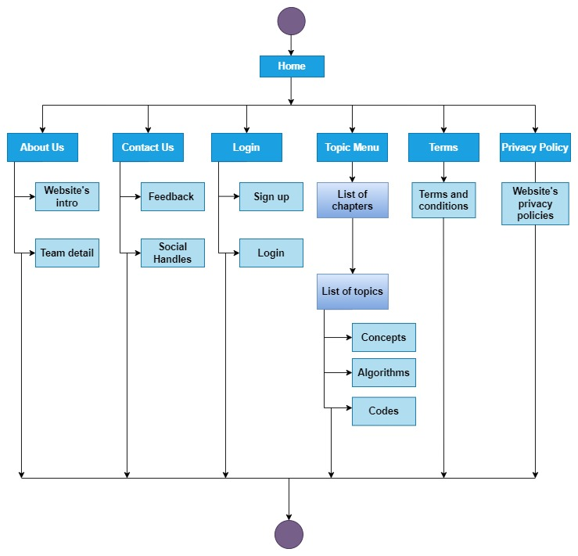

**CHAPTER 4 Sample Screenshots**

1. 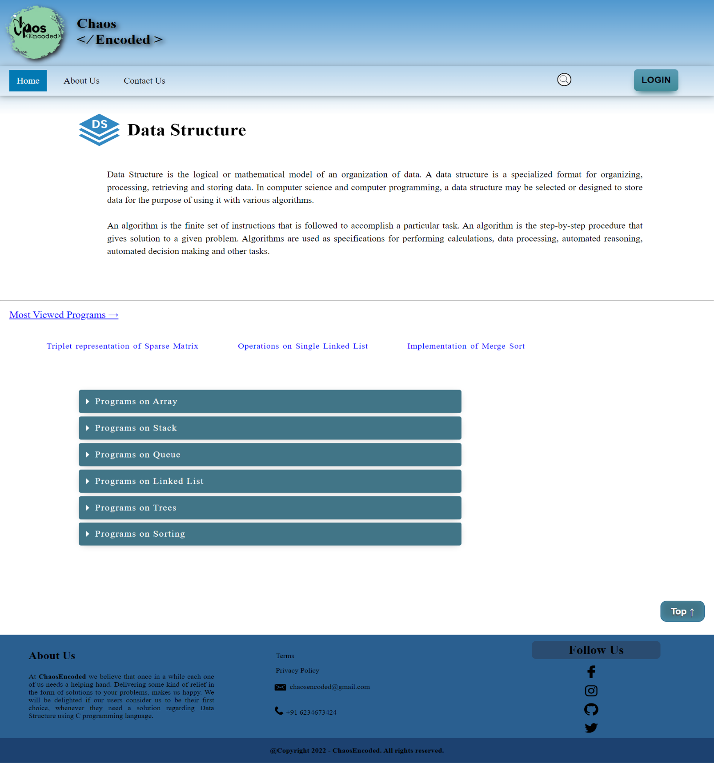**Home Page**
2. **Contact Us**

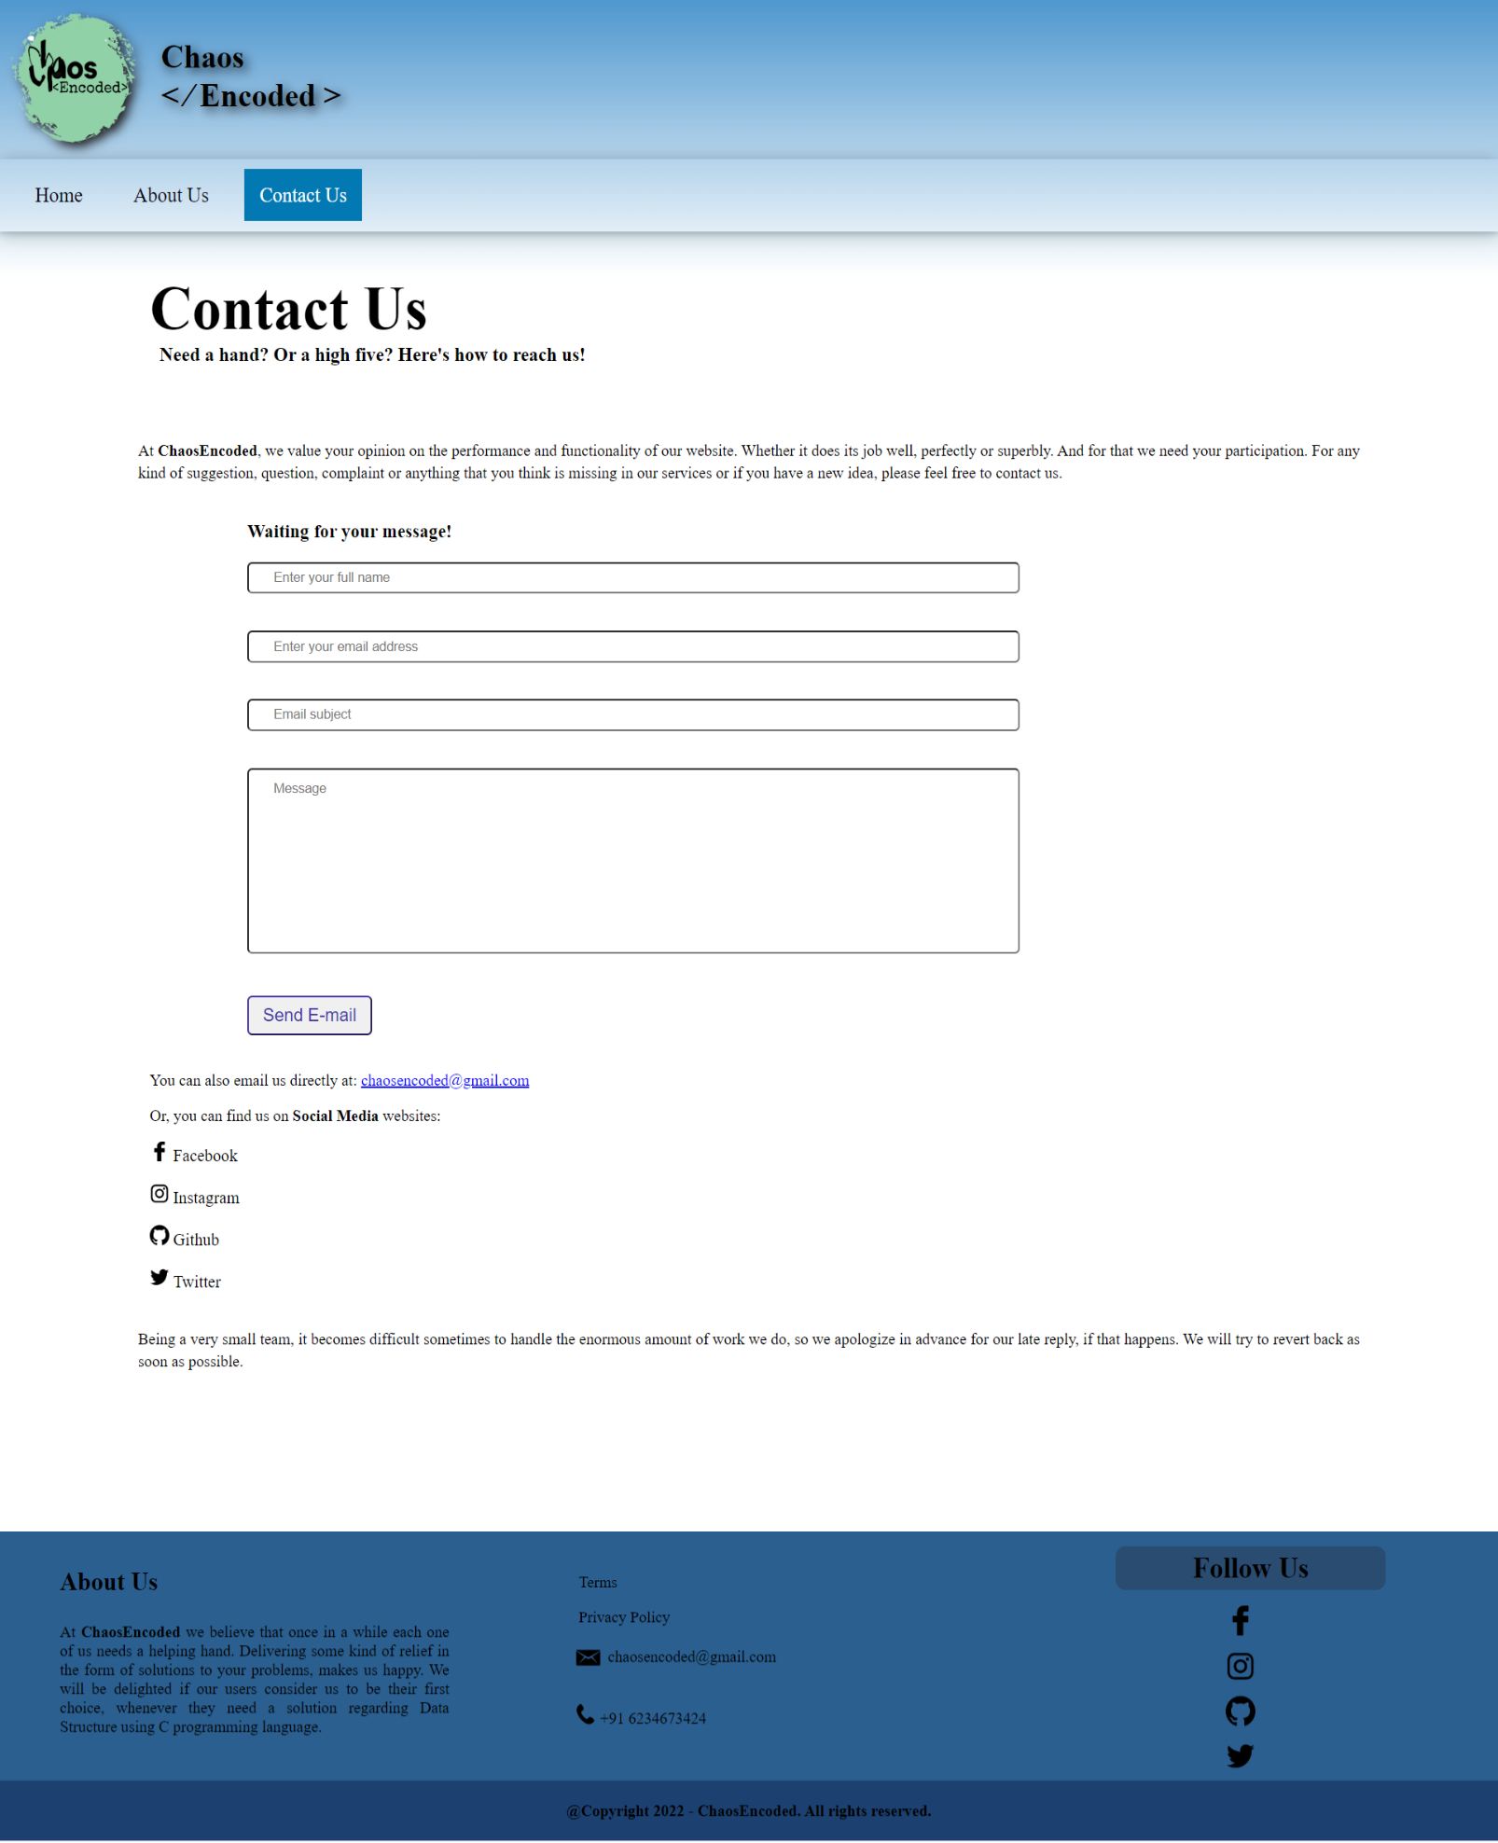

1. 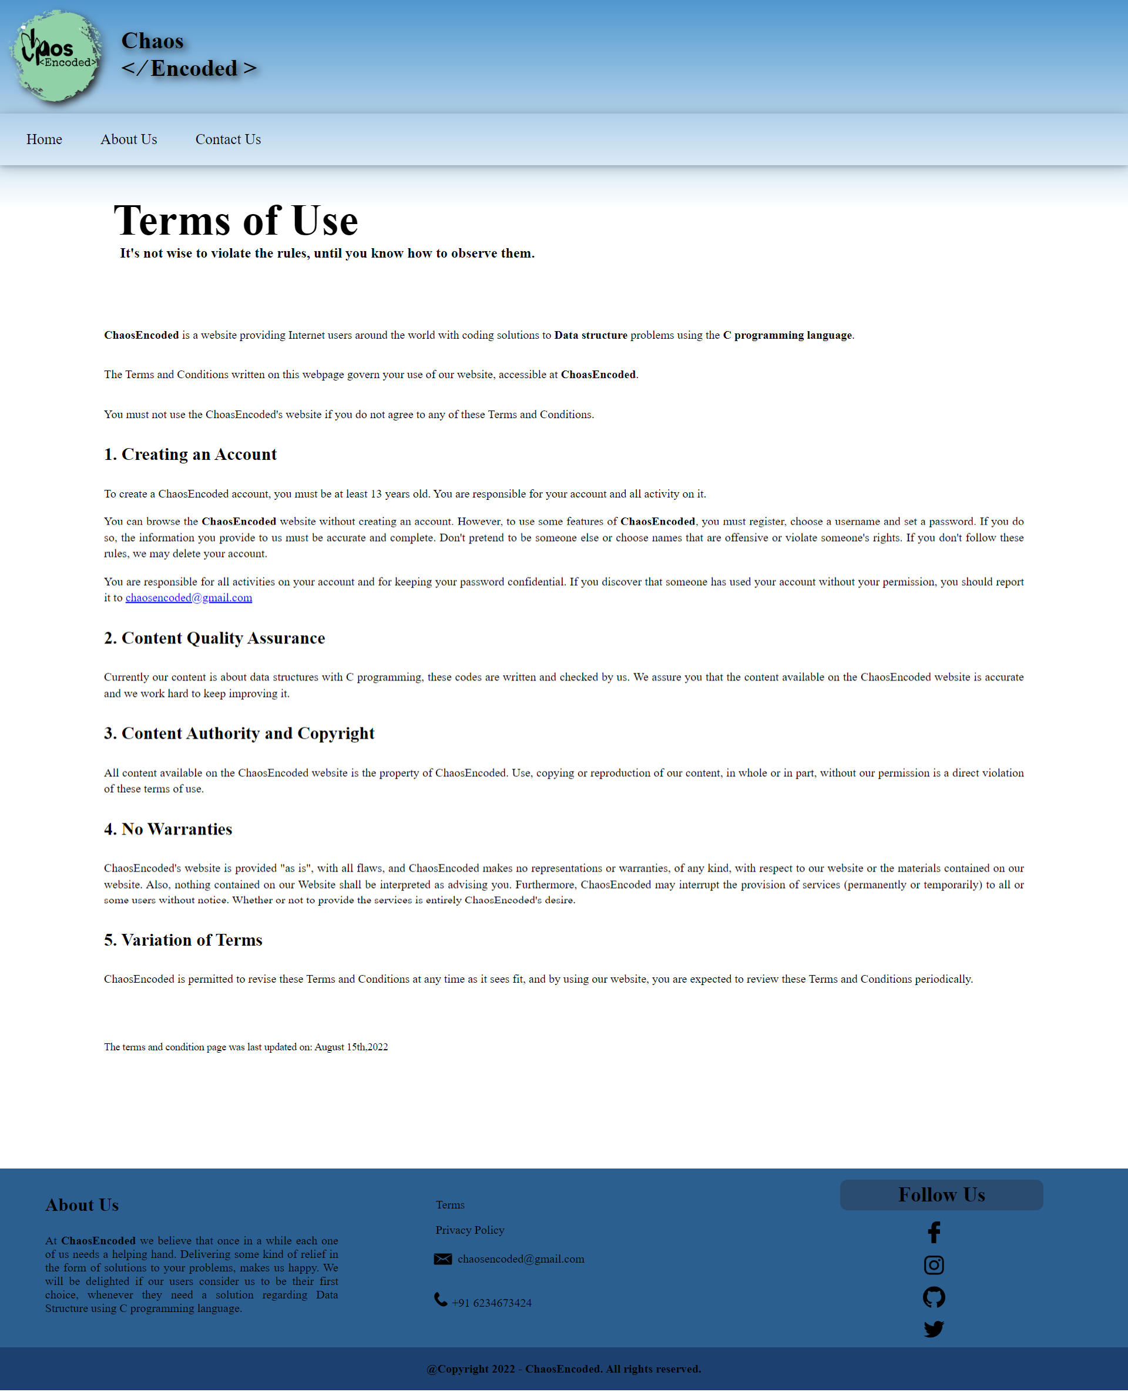**Terms & Condition**
2. **Privacy Policy**

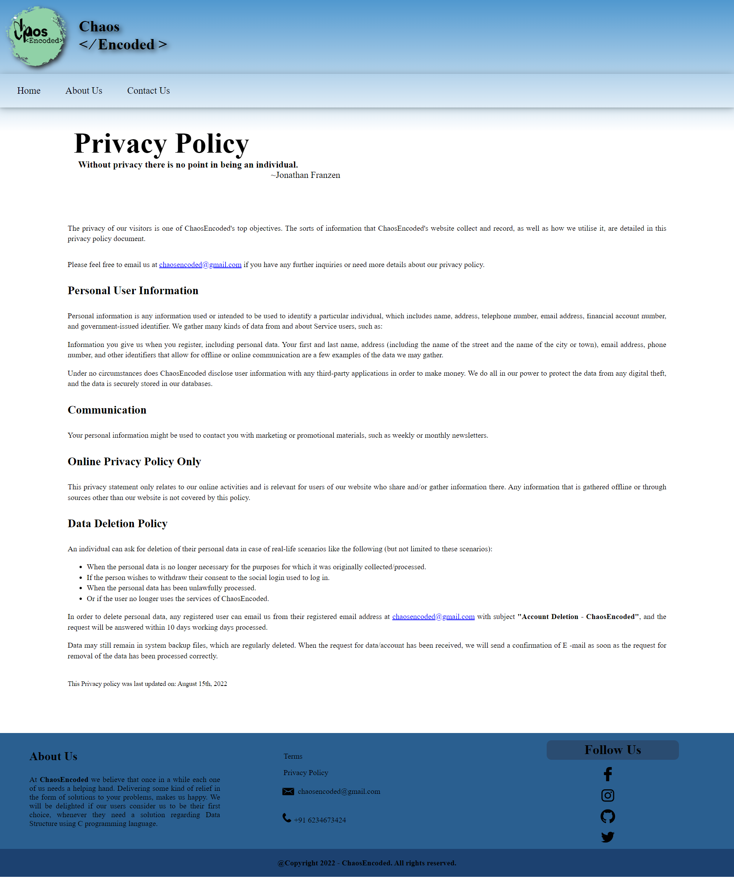

1. **Login Page**



1. 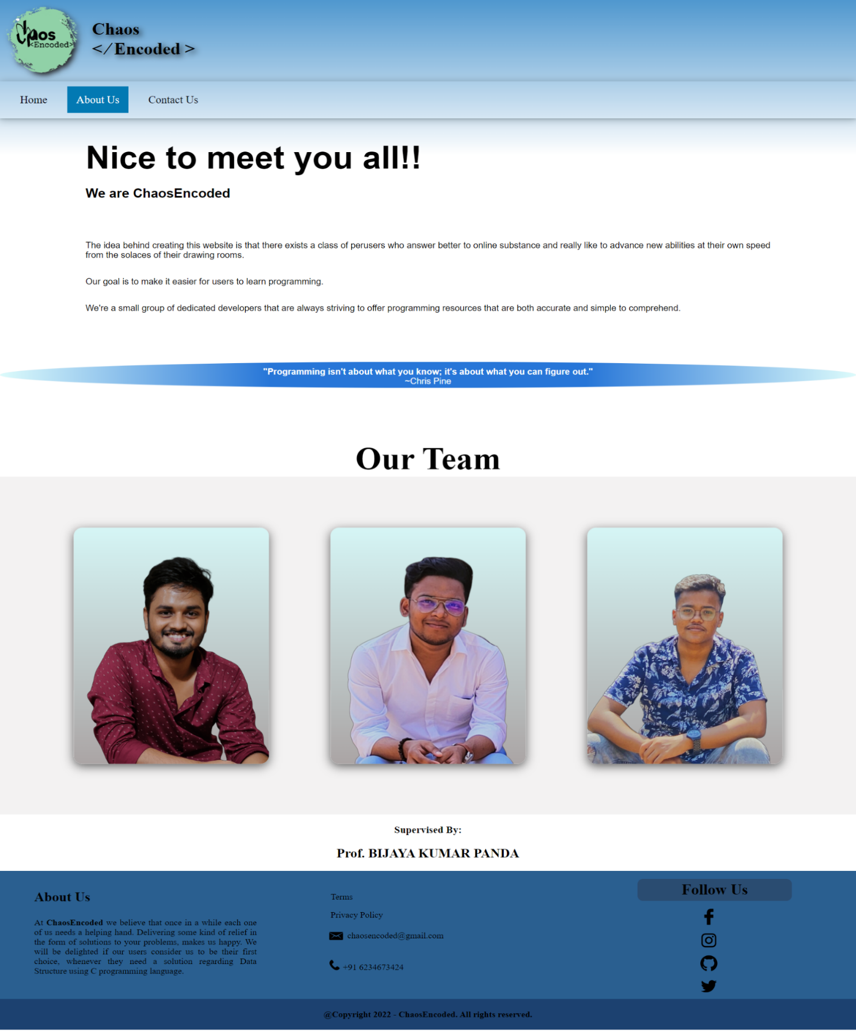**About Us**
2. 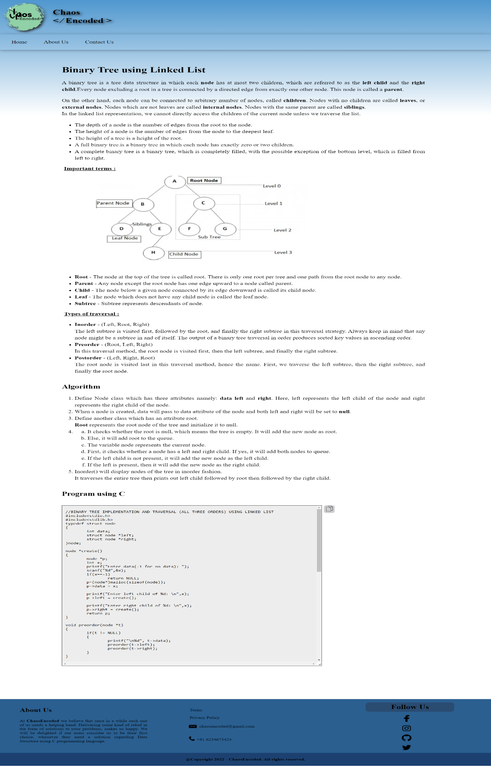**Topic Screenshots**

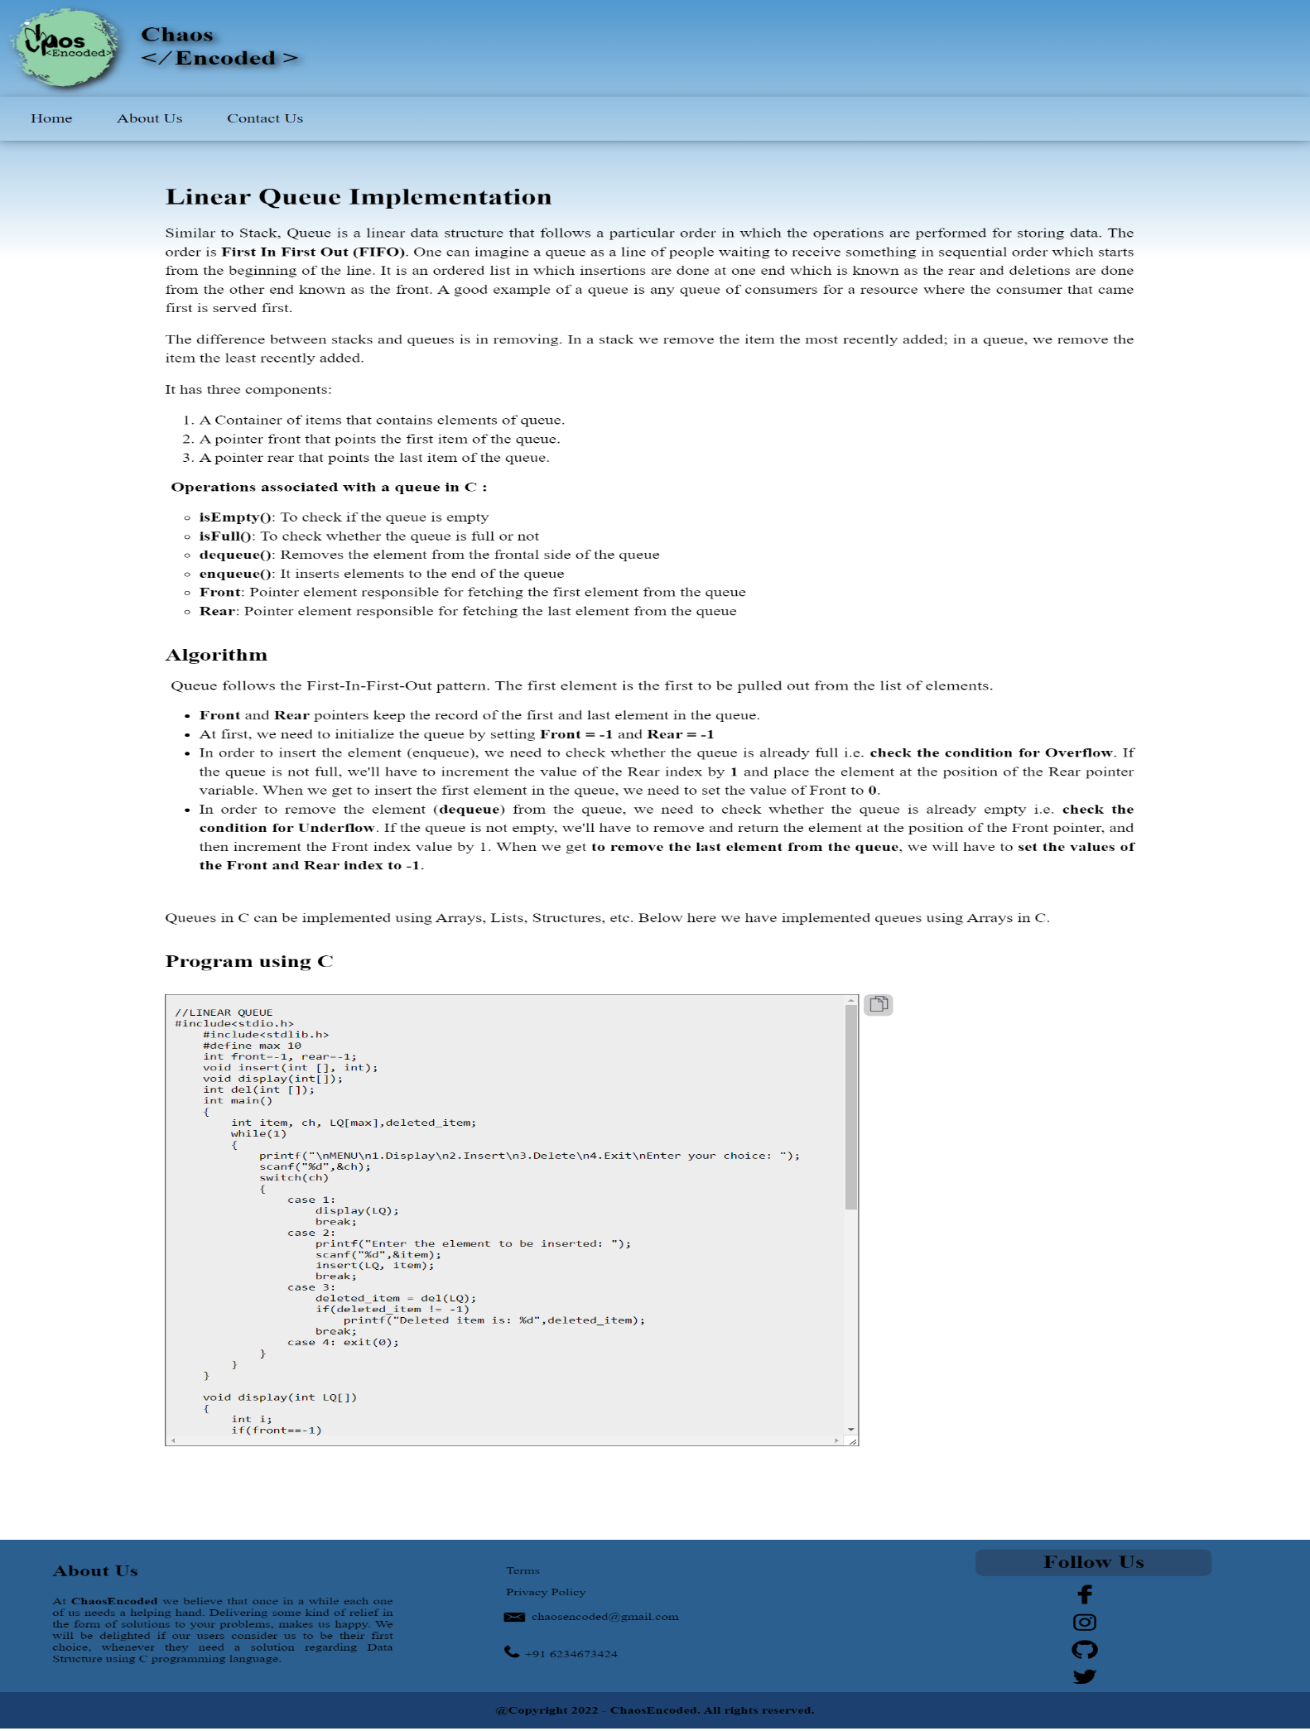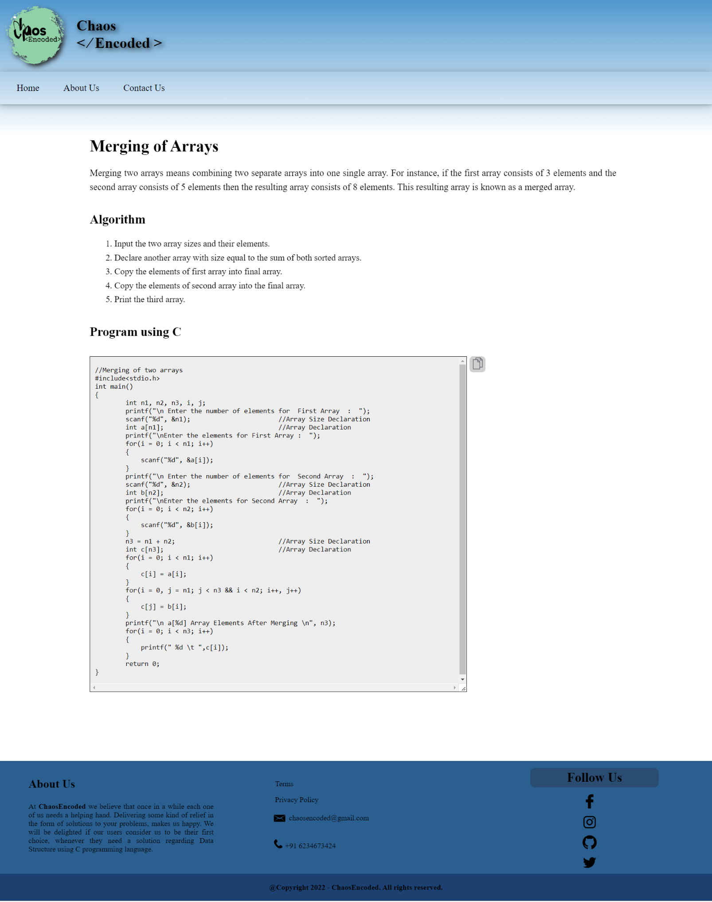

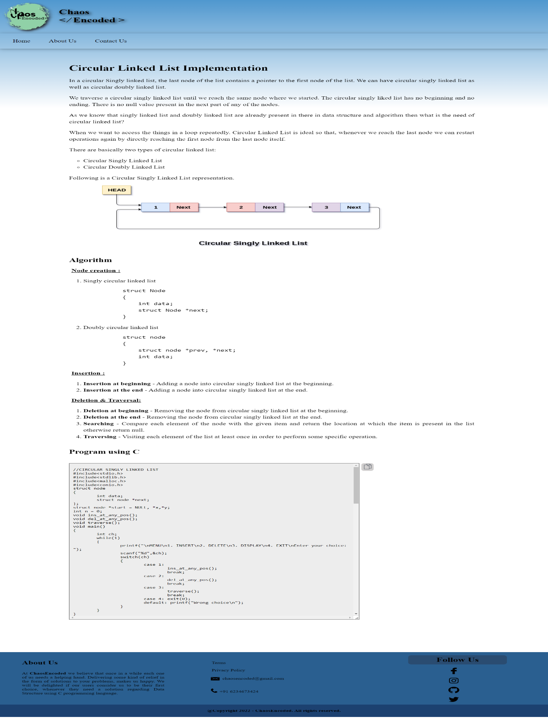

**CHAPTER 5 Coding (As Attachment)**

The coding part of the project “ChaosEncoded – Tutorial Website”

is attached separately in the email.

**CHAPTER 6 Conclusion & Future Work**

**6.1 Conclusion**

Wrapping up, ChaosEncoded aims at catering the need of students of 3rd semester, who are studying Data structure and all the others who want to revise their Data Structure.

Data structure, being a crucial chapter, considering its vastness and importance, demands a lot of effort. We found that it is really exhausting to find to all the relevant information regarding this at one place and because of which the project took a lot of time. So, we wanted to come up with a solution which will cater to our needs.

Here, ChaosEncoded comes into the picture. It will help you in finding all that you need regarding Data Structure using C programming. We, as students, empathize with you and only after doing that we came up with this idea. We look forward to be your helping hand in the moment of distress. Serving you, delights us.

**6.2 Future Work**

Currently we have only worked on the topics of Data Structure using C programming language. But in the future, we are planning to add the following to our website.

* Tutorials on programming languages like JAVA, C, Python etc.
* Full Stack Web Development.
* Database Management System (DBMS)
* Integrated Online Compiler of multiple languages.
* Other subjects like Computer Architecture, Data Analysis & Algorithms.
* Data Structure using JAVA, C, C++ and Python.
* Improving our content by adding more simplified solutions and visual aids.